Facebook: <https://www.facebook.com/profile.php?id=100072490028012>

Google Analytics:

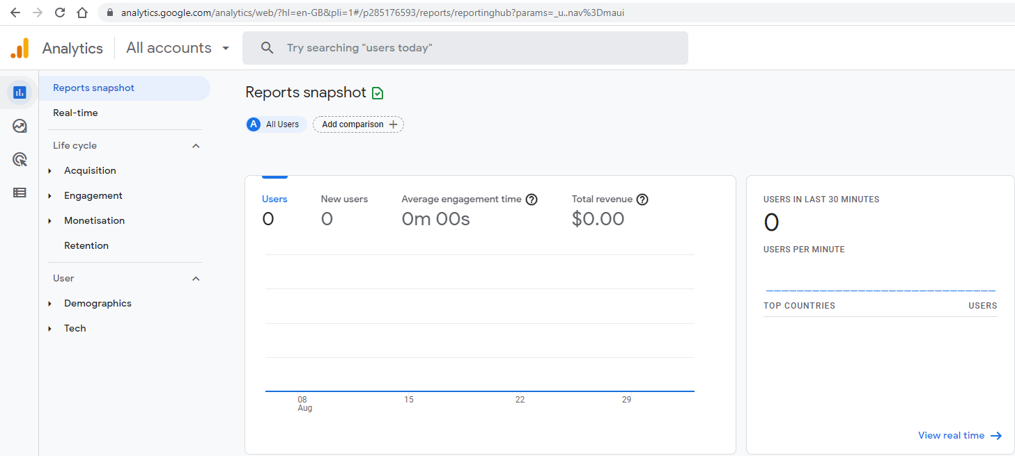

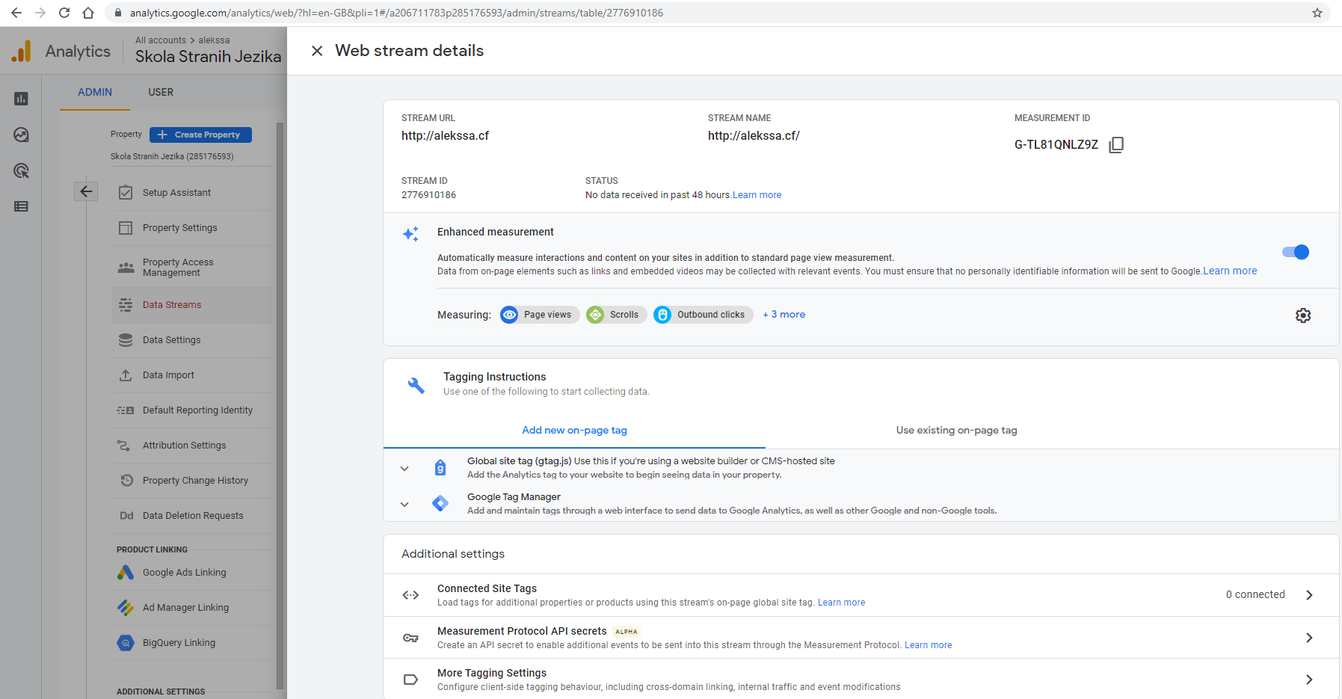

Baner:

